### Patent Data Overview

#### Overview—

* **Total Number of Patents**: 34

#### Patent Application Yearly Trend

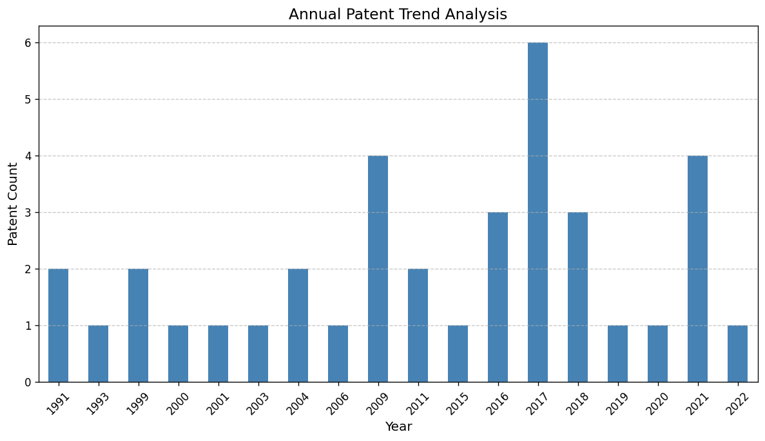

Trend Chart

#### Patent Distribution by Country/Region

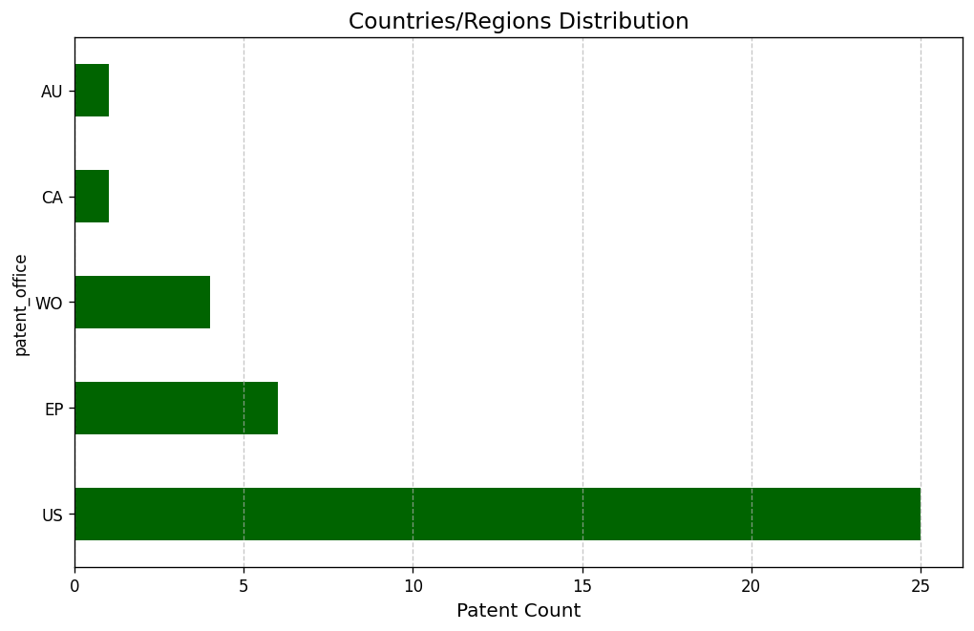

Country Patent Chart